Practical No. 13

Aim: Create a table and perform the search operation on table using indexing and non-indexing techniques.

Theory:
Create a table and perform the search operation on table using indexing and non-indexing techniques. Indexing is a database technique used to improve the speed of data retrieval operations on database tables. It involves creating data structures (indexes) that store a subset of the data in a more efficient format. Non-indexing techniques refer to methods of data retrieval that don't rely on traditional indexes. These techniques can include full table scans, sequential searches, and various data storage and access strategies, such as partitioning, materialized views, and data denormalization

Queries:
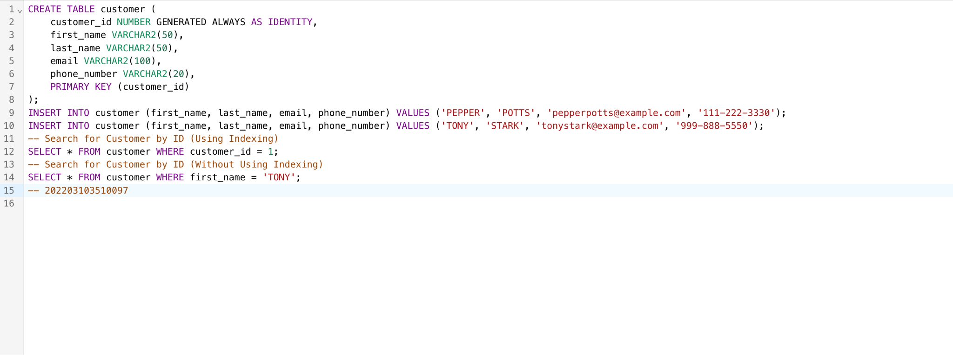

Conclusion: In summary, indexing techniques improve data retrieval speed by creating structured data structures, while non-indexing techniques encompass various methods that can be employed when indexes may not be the best solution or when specific data access strategies are needed.

